Name_Surname: 08.12.2020
Student Number:
EE231 Midterm Exam I

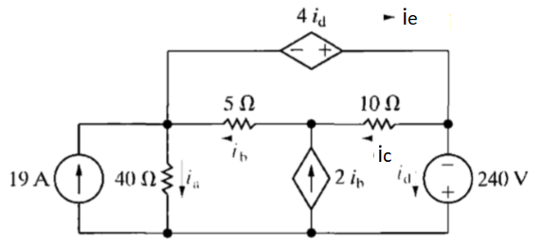
Figure 1
- (10 pts) Use the node-voltage method to find the branch currents i_{a} – i_{e} for the circuit shown in Figure 1.
- (10 pts) the mesh-current method to find the branch currents i_{a} – i_{e} for the same circuit.
- (5 pts) Check your answers by showing that the total power generated equals the total power dissipitated.

- (25 pts)
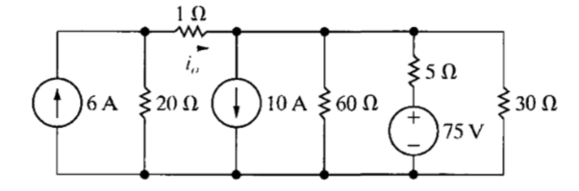
Figure 2
Use a series of source transformation to find the current i₀ in the circuit shown in Figure 2.

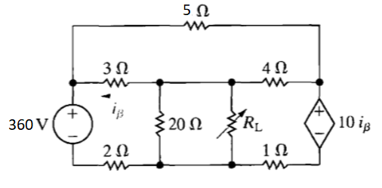
Figure 3
The variable resistor R_{L} in the circuit in Figure 3 is adjusted for maximum power transfer to R_{L}.
- (10pts) Find the numerical value of R_{L}.
- (15 pts) Find the maximum power transferred to R_{L}.

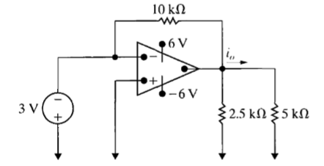
- (25 pts)
Figure 4
Find i₀ in the circuit in Figure 4 if the op amp is ideal.

